SSL-RENEWAL IN TOMCAT
- GETTING DETAILS FROM App Team:
- For any SSL-Renewal we require Application details along with the server/Host names and port numbers.
- We generally follow the same method of asking the application details in the below tabular form for every SSL-Renewal.

Please find the below tabular form used for getting the app details from the Application Team:
Application URL*
Webserver hostname, Port# *
Application name*
Gear ID *
Business Contact Person *
Business Contact email *
Business Contact Phone *
Application support DL email id *
CBD code (Charge code) *
* Mandatory

- The application team will provide the requested details accordingly.
- For example, here the table which is filled by the application team in the above format.

Please find the below Table provided by application team:
Application URL* | https://publishonline.aig.net
Webserver hostname, Port# * | plgsascs2455000/plgsascs2455006, 16020
Application name* | CLAIMS-ICORR
Gear ID * | 2455
Business Contact Person * | Swapnil Dabholkar
Business Contact email * | swapnil.dabholkar@aig.com
Business Contact Phone * | +1 704 619 7421
Application support DL email id * | Icorr_core_team@aig.com
CBD code (Charge code) * | 010006690620
* Mandatory

Once, we get all the required details the next step we have to follow is raising CSR for the cert which is going to expire.

- RAISING CSR:
- We have to raise the CSR in order to get the new certs while raising the PKI CSR details is required.

CSR RAISING PROCESS:
- We have to logion to the “plgsascs5197002” server and navigate to the below path:
Path: /app/automation/SSL_SCRIPT
- Execute the run.sh script now,
Command: ./run.sh

After running the script it will ask for the below shown details:

- 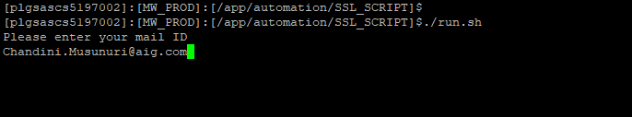

- As, part of the cert Renewal we have to select the listed options:

Here, we’ve selected (1) option as we are requesting for the Renewal:
- 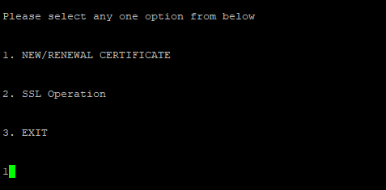
- We have selected option (1) as we are raising the new CSR for the cert.
- 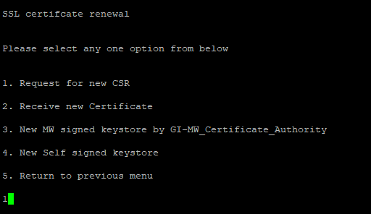

- We have to select the product where it should get added.
As,the serevers for this application is running on IBM product,we’ve selected Option(1)
- 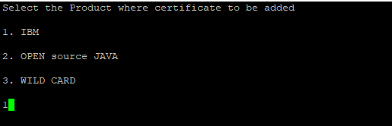

- We’ve to provide the CN name of the certificate which is nothing but we can get it from either server/ we can also get it from the app details provided by application team.
- 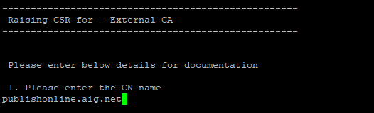

- We have to provide the application name from the details provided by app team:

- 

- Enter the Gear ID from the app team provided details:

- 

- Please click on enter to raise the CSR by cross verifying the provided details:
- 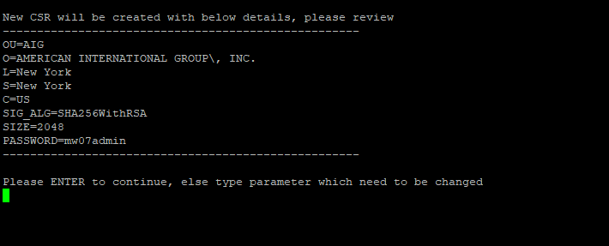

- RAISING PKI REQUEST:
- We have to raise SN REQ for PKI team to get the latest certificates.
- Navigate, to Service Now sp portal and search for “PKI” and select the first option as shown below:
- 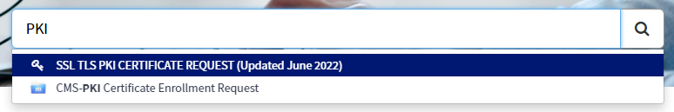
- Please fill all the mandate fields with appropriate and accurate details.
- We can get the Application name, Business contact person, Team DL from the details provided by Application team.
- 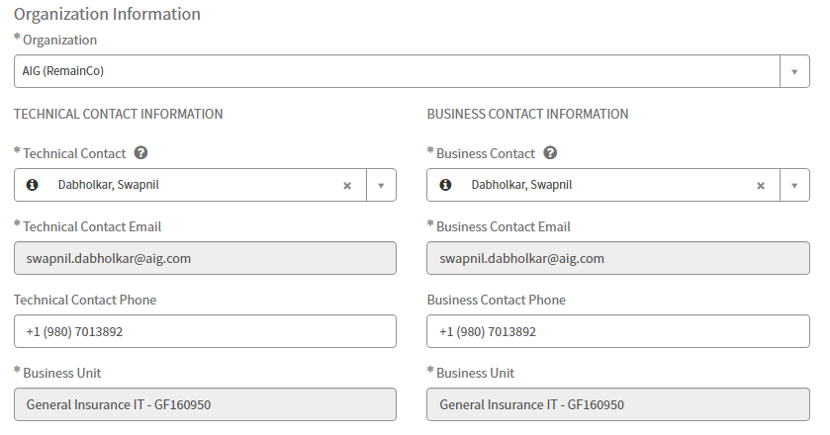

- 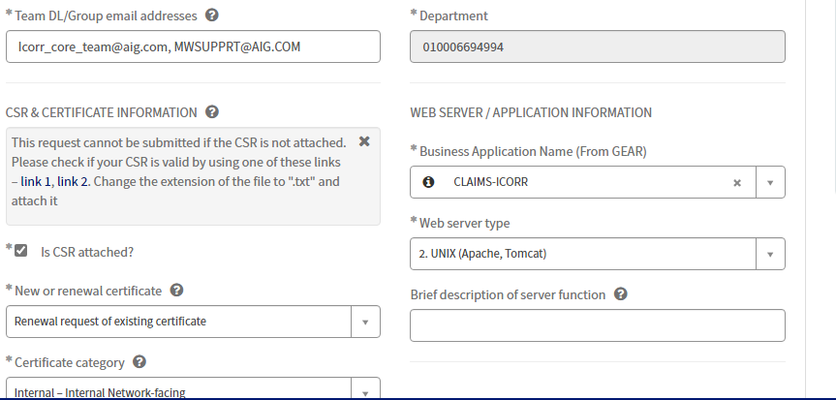

- 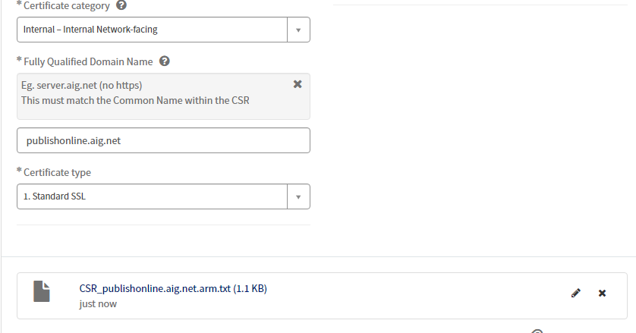
- We have to attach the CSR in txt format while submitting the REQ to PKI Team as above.
- How do we get the arm file..?

- Browse the link provided in the email generate when we raise the CSR
http://mwutility.aig.net/ssl/RENEWAL/publishonline.aig.net/IBM_CA_CSR_0609220808
- And copy the arm file and change it to the txt format
- 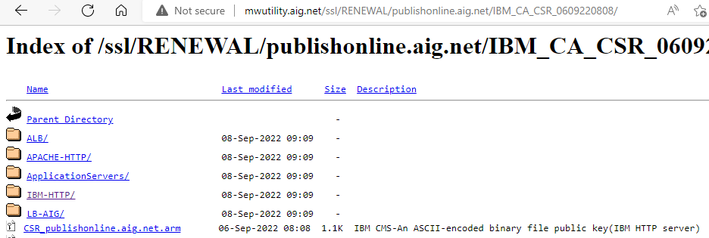
- After submitting the REQ, Email to PKI team requesting for the new certs to be added.
- PKI Team will provide the new certs for us via email as attachments:
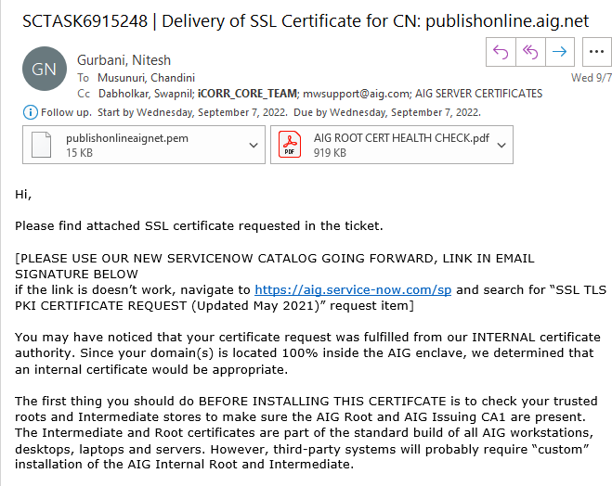

- Copy the pem cert to your local and change the type of the file into txt file.
- Also, copy the pem file as it is and save in your local system.

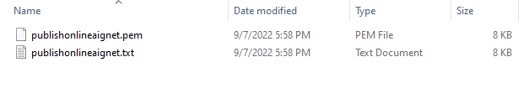

- RECEIVING CERTIFICATES:
- We have to receive the latest certs into our servers.
- Login to the SSL Server (i.e., plgsascs5197002) and follow the below process.
- Navigate to the below path.
Path: /app/automation/SSL_SCRIPT
And run the run.sh script.
Command: ./run.sh
- Provide the required details:
- 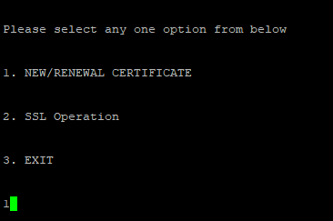
- We have to select the 2nd option as we are seeking for new certificates.
- 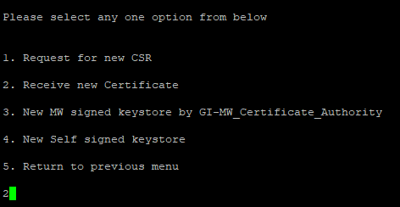
- 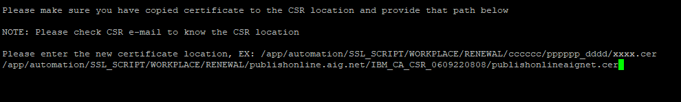
- Have to update the certificate path from the CSR along with the certificate
Path: /app/automation/SSL_SCRIPT/WORKPLACE/RENEWAL/publishonline.aig.net/IBM_CA_CSR_0609220808.
- For the certificate to provide in the above path we have to follow the below process.
- Take the below path from the CSR email and navigate to the path
Path: /app/automation/SSL_SCRIPT/WORKPLACE/RENEWAL/publishonline.aig.net/IBM_CA_CSR_0609220808/

- 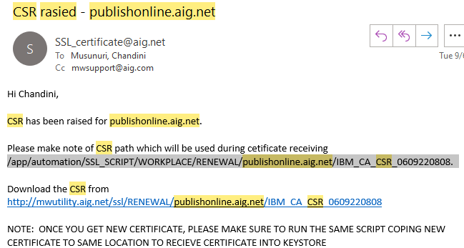
- We have to create a file with the name of our cert as exactly as the CN name but the extension should be in .cer format(publishonlineaignet.cer)
Command: vi publishonlineaignet.cer
and copy the latest cert of publishonlineaignet.txt(from our local to the server).
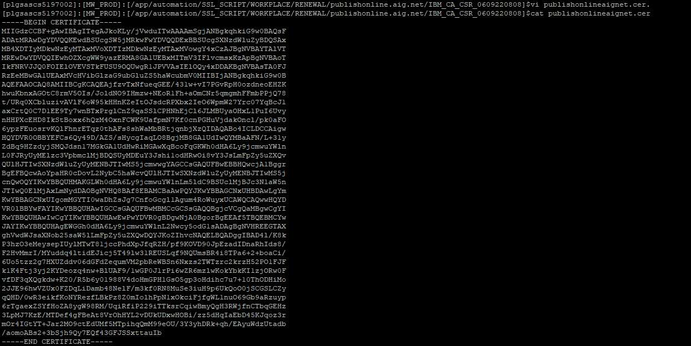

NOTE: Please make sure to copy the correct cert into the server provided by PKI Team.(From BEGIN CERTIFICATE TO END CERTIFICATE).
- We have to Provide the path along with the certificate name as shown below:
- 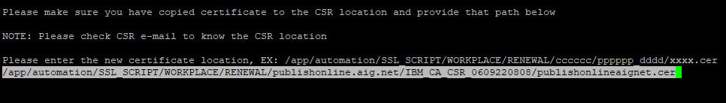

- Adding Latest certs in the server:
- Login to the servers where we have to add the certs.
- Login to “algsascs2455000” server and netstat the port number given by App team and find the process running on it.
- As, it is running on IBMIHS85 grep the conf file to find the kdb path.

Command: grep -i kdb /app/IBMIHS85/conf/httpd_onlinepublish_local.conf

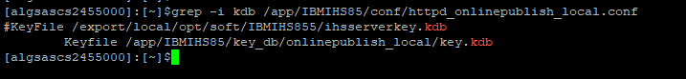

- Now, take the kdb path from the result which is in uncommented state.
- Here, we took
/app/IBMIHS85/key_db/onlinepublish_local/key.kdb path
- Navigate , to below path and open the key.kdb path and check the certificates present under the key.kdb file.
Path: cd /app/IBMIHS85/key_db/onlinepublish_local/
Command: cat key.kdb (to open the file)
- Now , using the below command list the certs present in the key.kdb path from apachectl bin path.

Command: ./gskcmd -cert -list -db /app/IBMIHS85/key_db/onlinepublish_local/key.kdb

- It will ask for the password, For any HIS servers the default password is “mw07admin”.
- It will give the result of all the certs present under that .kdb file as below.
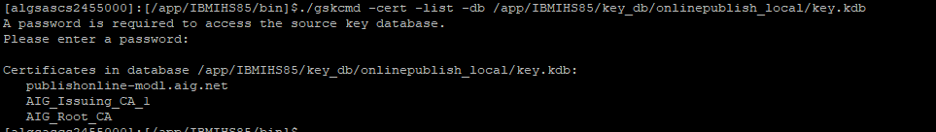

- Select any of the cert rom the result which you are looking to renew.
- In this case, we want to Renew the “publishonline-modl.aig.net” cert.
- To find the details of the “publishonline-modl.aig.net” cert we have to use the below command from bin path.
Command: ./gskcmd -cert -details -db kdb path -label labelname
EXAMPLE Command: ./gskcmd -cert -details -db /app/IBMIHS85/key_db/onlinepublish_local/key.kdb -label publishonline-modl.aig.net
- It will again ask for the password. As mentioned above use the default password (mw07admin).
- Find the cert validity(i.e., from when the cert is valid and till when the validity expires from the result)
- CERTIFICATE IMPORTING:
- To import the certificate we need to copy the latest key.kdb/key.rdb/key.sth files from the email.
- 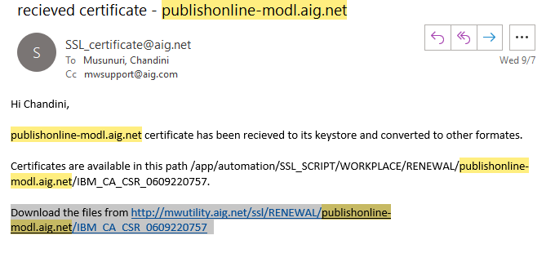Browse, the from http://mwutility.aig.net/ssl/RENEWAL/publishonline-modl.aig.net/IBM_CA_CSR_0609220757 URL and click on IBM-HTTP where we can find the latest key.kdb/ley.rdb/key.sth files.

  - 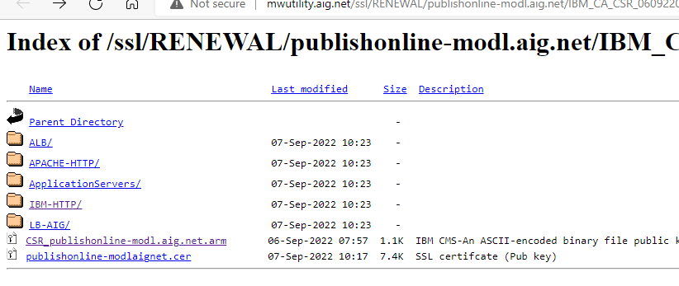
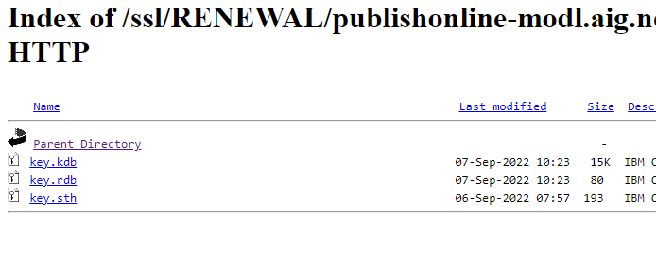
- We have to install the latest kdb/rdb/sth files to our server where we wanted the certs to be installed.
- Navigate to “/app/IBMIHS85/key_db”
- Create a directory as “onlinepublish_local_new” under “/app/IBMIHS85/key_db” path.
- Now, go to below path:
Path: cd /app/IBMIHS85/key_db/ onlinepublish_local_new
- Install the latest kdb/rdb/sth files into this path using the below command.
- Command: curl -O http://mwutility.aig.net/ssl/RENEWAL/publishbatch-modl.aig.net/IBM_CA_CSR_0609220944/IBM-HTTP/key.kdb

- curl -O http://mwutility.aig.net/ssl/RENEWAL/publishbatch-modl.aig.net/IBM_CA_CSR_0609220944/IBM-HTTP/key.rdb

- curl -O http://mwutility.aig.net/ssl/RENEWAL/publishbatch-modl.aig.net/IBM_CA_CSR_0609220944/IBM-HTTP/key.sth

We have copied all the latest files to our server.
- Verify the key.kdb file to know the certs present under the .kdb file is latest or not.
Navigate to bin path,
Path: cd /app/IBMIHS85/bin
Execute the below commands to check the validity.

Command: ./gskcmd -cert -list -db /app/IBMIHS85/key_db/onlinepublish_local_new/key.kdb

Command: ./gskcmd -cert -details -db /app/IBMIHS85/key_db/onlinepublish_local_new
/key.kdb -label publishonline-modl.aig.net

- We have made the setup ready.
- To proceed the renewal we have to follow the below steps:

NOTE: Make sure we are updating the latest certs by thoroughly checking

- Navigate to bin path and Stop the server running on 16020(port number)
Command: ./apachectl_onlinepublish_local start

- Navigate to below path:
cd /app/IBMIHS85/key_db/onlinepublish_local/

- Rename the “ONlinepublish_local” to “onlinepublish_bkp_REQ5030944”
Command: mv onlinepublish_local onlinepublish_local_bkp_REQ5030944

d)Make the onlinepublish_local_new file as main file
command: mv onlinepublish_local_new onlinepublish_local

- Go to bin path and start the apachectl
Path: cd /app/IBMIHS85/bin
Command: ./apachectl_onlinepublish_local start

- To confirm, the latest certs are updated go to bin path and check the details of the cert using below command.

Command: ./gskcmd -cert -list -db /app/IBMIHS85/key_db/onlinepublish_local/key.kdb

./gskcmd -cert -details -db /app/IBMIHS85/key_db/onlinepublish_local/key.kdb -label publishonline-modl.aig.net.

Wherein we can see the validity from the result.
- We can also check the validity from the URL provided by the App team,
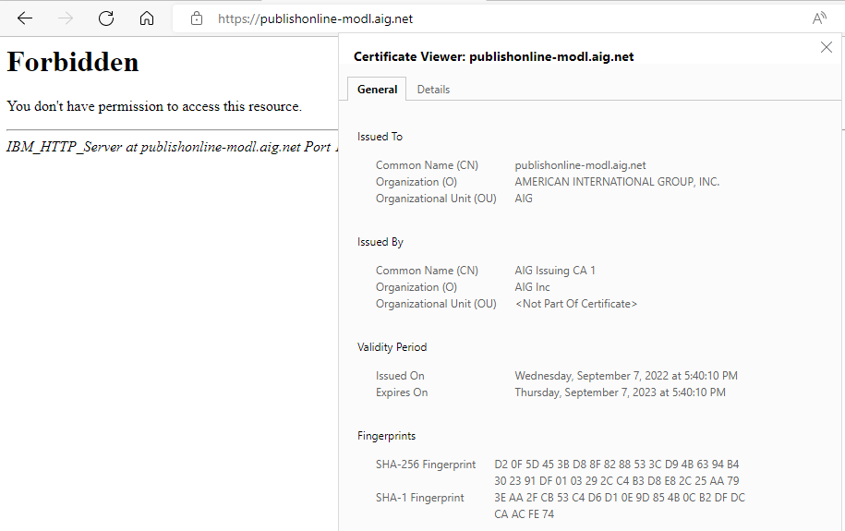

- PROD RENEWALS:

- For production region Renewals, we have to schedule a change in the weekend with all the details and inform the app team about the downtime of the application in that period. Also, will ask App team to be available for AVP after implementing the Renewal process.

NOTE:
- Before proceeding to Renew the certificates we have to raise an RFI REQ to the LB team to check whether the cert is present from LB end or not.
- If the cert doesn’t exist on LB end we can proceed to add the latest certs in the server.
- If the cert is present under LB end we have to raise an RFS asking LB team to add the cert from LB end as well.

